Successful Channels Salesforce Package Installation Guide

About Successful Channels Managed Package and Released Version 2

Install the SC Managed Package 2

Install the Successful Channels Managed Package on your SFDC sandbox/test account? 2

How to Install the Successful Channels Managed Package on your SFDC production/live account? 2

Level 1 Sync: Map Data from Client / Standard Objects to SC (Successful Channels) Salesforce Custom Objects 3

Step 1: Add Data Type in Custom Settings 3

Step 2: Map Objects and Fields 5

Step 3: Use Filters and Data Type in Object Mapping 8

Step 4: Copy data from Client Objects to Successful Channels Custom Objects 8

Step 5: Automatically copy data from Client Objects to Custom Objects 9

Level 2 Sync: Synchronize data from the Successful Channels Custom Objects with the Successful Channels web application 10

Step 1: How to Setup Level 2 Sync 10

Step 2: How data copy from Salesforce to SC Application 11

Step 3: How to Validate Synced Data into SC Application 11

User Access/Permission 12

**Salesforce Managed Package Guide**

# About Successful Channels Managed Package and Released Version

The Successful Channels managed package is designed to support two directions of data synchronization with Salesforce.   
**1) Level 1:** Client Object ***to*** SC Custom Object data sync  
**2) Level 2:**  SC Custom Object Sync ***to*** SC web application

Users can perform these operations by following the instructions below.

The current released version is **V1.19**

# Install the SC Managed Package

How to Install the Successful Channels Managed Package on your SFDC Org

## Install the Successful Channels Managed Package on your SFDC sandbox/test account?

To install the package into your SFDC sandbox account, you need to follow the below instruction

1. In your browser, go to: test.salesforce.com
2. Log in to your sandbox account
3. After login, use the link:

<https://test.salesforce.com/packaging/installPackage.apexp?p0=04t6F000001ovzt>

Click on **“Install”** if the package is not installed and **“Upgrade”** if you are installing an updated version of the previously installed package.

## Install the Successful Channels Managed Package on your SFDC production/live account?

To install the package into your SFDC sandbox account, you need to follow the below instruction

1. In your browser, go to: login.salesforce.com
2. Log in to your sandbox account

After login, use the link: <https://login.salesforce.com/packaging/installPackage.apexp?p0=04t6F000001ovzt>

1. Click on **“Install”** if the package is not installed and **“Upgrade”** if you are installing an updated version of the previously installed package



# Level 1 Sync: Map Data from Client / Standard Objects to SC (Successful Channels) Salesforce Custom Objects

After installing the Salesforce SC package in your salesforce account, it is essential to do some settings before using the salesforce package. These steps should be followed in the exact order listed below.

## Step 1: Add Data Type in Custom Settings

1. Log in to salesforce account
2. From the right-side header, click on **“Setup.”**

Click Here

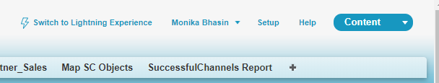

1. In the left navigation quick search enter **“Custom Settings”** and select “**Custom Settings”** from the list

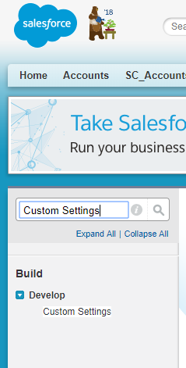

Select

Type Here

1. On Custom Settings, select **“[SuccesfulChannelsDataType](https://cs92.salesforce.com/01I3F00000056e9?setupid=CustomSettings)”** by clicking on **“Manage.”**

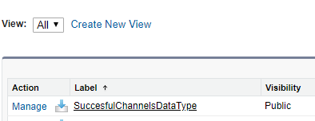

Click Here

1. To add **Data Types,** click on **“New.”**
2. Fill the information one by one in the fields that appeared after clicking on **“New”**

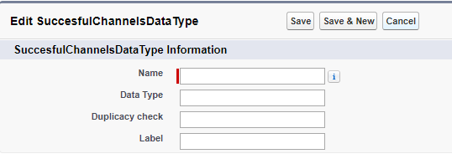

|  |  |  |  |
| --- | --- | --- | --- |
| Name | Data Type | Duplicacy Check | Label |
| SC_Planners__SC_Account__c | Partner Accounts | SC_Planners__Partner_Salesforce_ID__c | SC Account |
| SC_Planners__SC_Contact__c | Partner Contacts | SC_Planners__Contact_ID__c | SC Contact |
| SC_Planners__SC_Partner_Pipeline__c | Partner Pipeline | SC_Planners__Deal_Id__c | SC Partner Pipeline |
| SC_Planners__SC_Partner_Sales__c | Partner Sales | SC_Planners__Transaction_Id__c | SC Partner Sales |
| SC_Planners__SC_Accreditation__c | Accreditation | SC_Planners__Accreditation_Id__c | Accreditation |
| SC_Planners__SC_PartnerProfile__c | Partner Profile | SC_Planners__Partner_Account_ID__c | SC Partner Profile |
| SC_Planners__SC_Task_Summary__c | Task Summary | SC_Planners__Task_ID__c | SC Task Summary |

## Step 2: Map Objects and Fields

Right now, we have One to Many Relationships in Object Mapping. We can map Client Object with different SC Application Custom Object.

1. Login to salesforce account
2. Install package
3. Add data type in custom settings
4. Click on **Map SC Objects** from the main navigation or if you do not have this option in the main navigation find **Map SC Objects** option under **“All Tabs”.**
5. Select the client object from the **“Salesforce Object to be Mapped”**

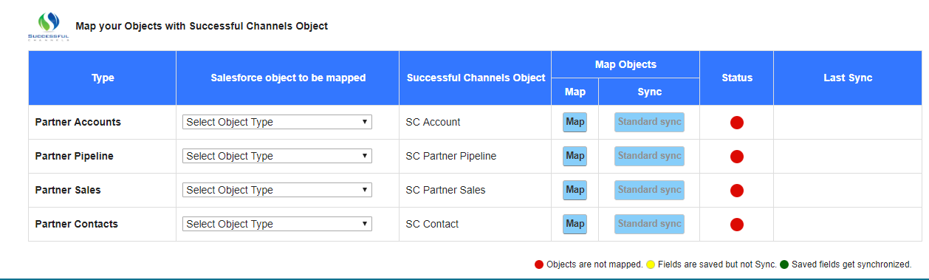

1. Select **Object Type** you wishes to sync data from this object type can be
   1. **Standard Object:** Object created or used by Salesforce default
   2. **Custom Objects:** Objects created by salesforce user 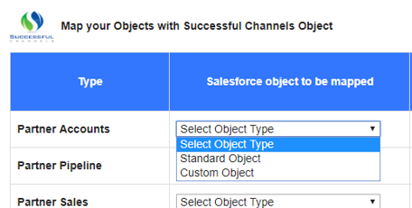
   3. After selecting **Object Type** it is required to **Select Object to Map**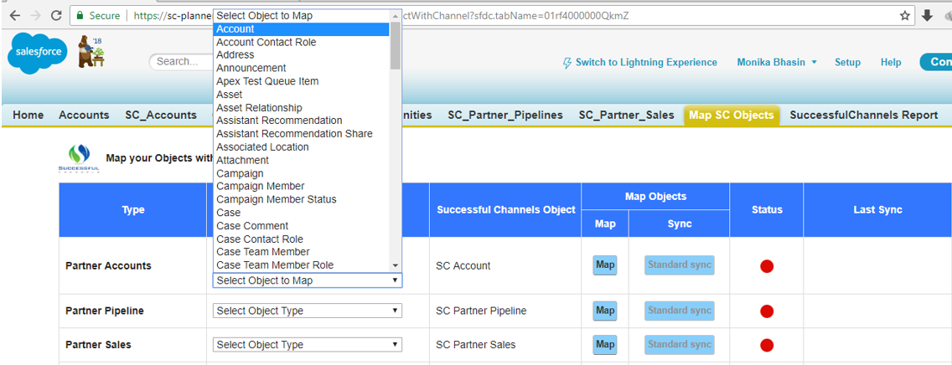
   4. Click on **Map**

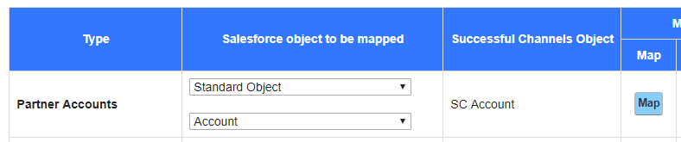

1. Select fields for the selected object type
   1. After clicking on **Map** button, a pop-up will appear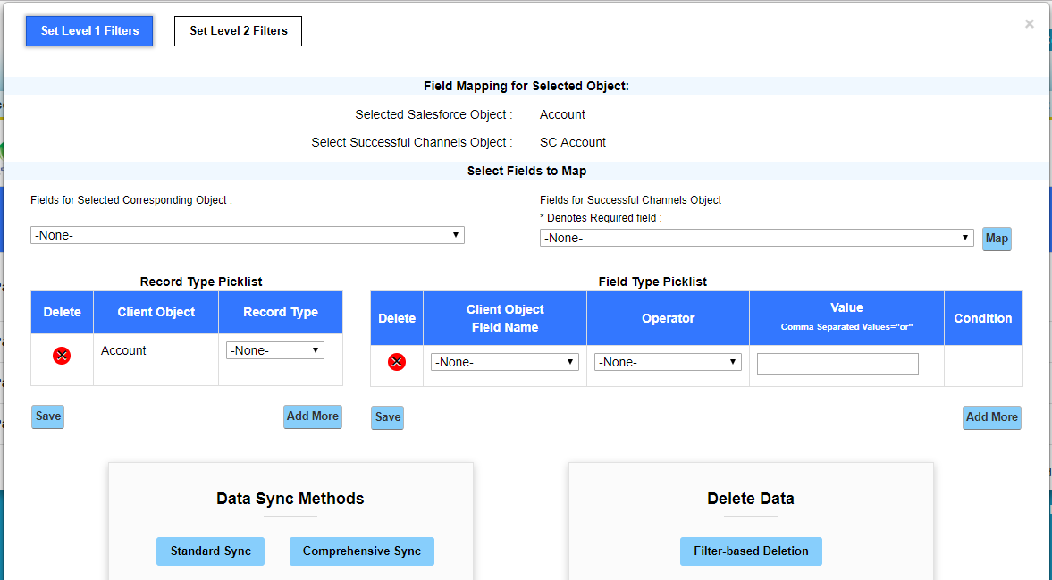
   2. In the left is the **Field for Selected Corresponding Object** and in the right is the fields for **Successful Channels Object**

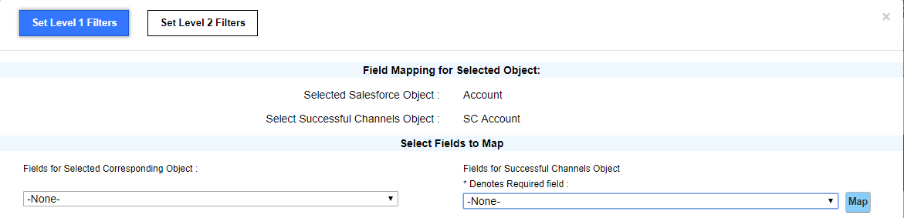

* 1. Click on the left dropdown to select the field object from which you want to copy data into SC salesforce object. Click on the right dropdown to select the field object in which the data from the field object selected from the left dropdown will be copied. For e.g. salesforce user wants to copy field object data of **Account Name** from right dropdowninto field object data of left dropdown **Partner Name.** Check the screen shot below

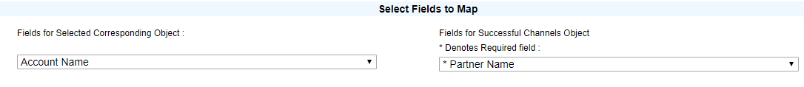

* 1. After selecting the field objects from Left drop down and right drop down click on the **Map** button located next to right dropdown

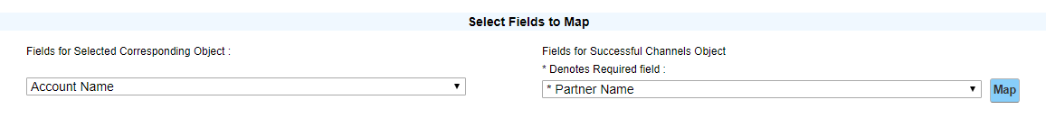

* 1. Every mapped field list at the bottom of the pop-up window
  2. It s required to map all the field with **asterisk** from the right dropdown to sync the data from salesforce standard object from left dropdown fields object.
  3. Repeat the same steps for other objects and fields

## Step 3: Use Filters and Data Type in Object Mapping

Right now, we can Restrict the data to copy into our Custom Object through Filters and through Record Type

## Step 4: Copy data from Client Objects to Successful Channels Custom Objects

1. There are two ways to sync data/records from salesforce standard object into SC salesforce custom object
   1. **Standard Sync:** This action sync data on basis of filters applied and picked the data after Last Sync Date
   2. **Comprehensive Sync:** This will sync all data from client Object to Custom Object on basis of filters set

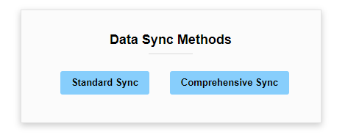

## Step 5: Automatically copy data from Client Objects to Custom Objects

We have Level 1 Auto Sync which automatically copy data from client Object to Custom Object after every 15 min. To use this feature admin must configure this Service through salesforce custom setting and Developer Console. To activate level 1 auto sync follow the below steps

1. Login to Salesforce Account
2. Click on **“setup”** from right
3. In the left navigation quick search enter **“Custom Setting”** and hit enter
4. On Custom Settings page click on **Manage** in front of [SuccessfulChannelsSyncSetting](https://na59.salesforce.com/01If4000001atG3?setupid=CustomSettings)
5. Click on **New**
6. In the **Name** field enter **RunAutoSync**
7. Click on Checkbox in front of SyncChannels unchecking the checkbox will stop level 1 syncing
8. Click on Dropdown icon listed with Salesforce account user name located in the right-side header
9. From dropdown select **Developer Console**
10. In developer console press ctrl+E or from the top header of developer console select Debug > Open Execute Anonymous Window
11. This action will open another window where you can enter the below code

System.schedule('SuccessfulChannelSyncScheduler Job 1','0 00 * * * ?', new SC_Planners.[SC_SyncScheduler](https://ap5.salesforce.com/01p7F000009dS0v)());

System.schedule('SuccessfulChannelSyncScheduler Job 2', '0 15 * * * ?', new SC_Planners.[SC_SyncScheduler](https://ap5.salesforce.com/01p7F000009dS0v)());

System.schedule('SuccessfulChannelSyncScheduler Job 3', '0 30 * * * ?',new SC_Planners.[SC_SyncScheduler](https://ap5.salesforce.com/01p7F000009dS0v)());

System.schedule('SuccessfulChannelSyncScheduler Job 4', '0 45 * * * ?',

new SC_Planners.[SC_SyncScheduler](https://ap5.salesforce.com/01p7F000009dS0v)());

System.schedule('SuccessfulChannelSyncScheduler Job 1','0 00 * * * ?', new SC_Planners.SC_SyncScheduler('SC_Planners__SC_Account__c'));

System.schedule('SuccessfulChannelSyncScheduler Job 2', '0 08 * * * ?', new SC_Planners.SC_SyncScheduler('SC_Planners__SC_Contact__c'));

System.schedule('SuccessfulChannelSyncScheduler Job 3', '0 16 * * * ?',new SC_Planners.SC_SyncScheduler('SC_Planners__SC_Partner_Pipeline__c'));

System.schedule('SuccessfulChannelSyncScheduler Job 4', '0 24 * * * ?', new SC_Planners.SC_SyncScheduler('SC_Planners__SC_Partner_Sales__c'));

System.schedule('SuccessfulChannelSyncScheduler Job 5', '0 32 * * * ?', new SC_Planners.SC_SyncScheduler('SC_Planners__SC_Accreditation__c'));

System.schedule('SuccessfulChannelSyncScheduler Job 6', '0 48 * * * ?', new SC_Planners.SC_SyncScheduler('SC_Planners__SC_PartnerProfile__c'));

System.schedule('SuccessfulChannelSyncScheduler Job 7', '0 56 * * * ?', new SC_Planners.SC_SyncScheduler('SC_Planners__SC_Task_Summary__c'));

1. Click on Execute

# Level 2 Sync: Synchronize data from the Successful Channels Custom Objects with the Successful Channels web application

## Step 1: How to Setup Level 2 Sync

1. Login to salesforce account
2. Click on **Setup** located in the Left side of the header
3. In the left quick search bar type **Custom Settings** and click on **Enter**
4. Click on “Manage” on the in front of **SuccessfulChannelsAPIUrl**.

Click on “Manage”

1. Graphical user interface, text, application, chat or text message

   Description automatically generated
2. Click on **New**
3. Enter Name and Enter API URL listed below all are required to be enter

|  |  |
| --- | --- |
| **Name** | **APIURL** |
| PartnerAPI | https://development.successfulchannels.com/salesforce_admin/add_partner |
| ContactAPI | https://development.successfulchannels.com/salesforce_admin/add_contacts |
| PipelineAPI | https://development.successfulchannels.com/salesforce_admin/add_pipeline |
| SalesAPI | https://development.successfulchannels.com/salesforce_admin/add_actuals |
| AccreditationAPI | https://development.successfulchannels.com/salesforce_admin/add_accreditation |
| PartnerProfileAPI | https://development.successfulchannels.com/salesforce_admin/add_partner_profile |
| TasksummaryAPI | https://development.successfulchannels.com/salesforce_admin/add_tasksummary |

1. In the left quick search bar enter **“Remote Site Setting”**
2. Click Enter
3. Click on **“New Remote Site”**
4. In Remote Site Name enter SuccessfulChannels
5. In Remote Site URL enter https://<clientname>.successfulchannels.com
6. Select the checkbox in front of **Active** to activate autosync and uncheck to deactivate autosync

## Step 2: How data copy from Salesforce to SC Application

1. There are some Standard parameters on which we copy the data from Custom Object to SC Application. And if those parameters don’t exist or value is blank- data will not copy from Salesforce SC custom Object to SC Application.
2. We fetch 1500 records same at a time from Salesforce to SC Application. This batch process runs in background.

## Step 3: How to Validate Synced Data into SC Application

To validate the data that is synced from SC salesforce object in SC Application follow the steps below

1. Go to https://<clientname>.successfulchannels.com/manageaudit
2. Enter Username
3. Enter Password
4. Click on **Login**
5. In the left navigation click on Manage Salesforce > Salesforce Login

Enter the Salesforce Details and click Submit.

1. When level 1 Sync occurred or manual sync (Standard/Comprehensive) – it will automatically call the callouts and inserts the data in SC Applications. To view the data – Go to the left navigation click on **Manage Salesforce > Salesforce Diagnostic Report**
2. On this page you can view how much data is Inserted, Updated or Not Synced because of some Error. Check the screenshot below 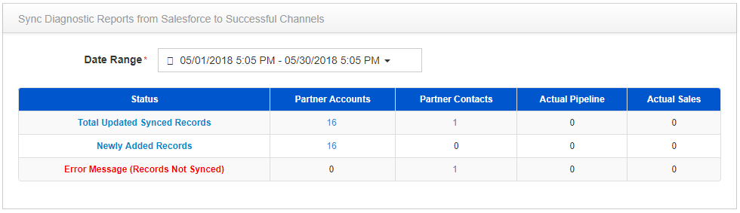
3. Clicking on the count will allow you to download a detailed excel sheet of the selected object

# User Access/Permission

Profile should have access of all SuccessfulChannels **Custom Objects/Custom Fields**.

1. Object permissions—“Read,” “Create,” “Edit,” and “Delete” enabled
2. Field-level security—set to visible and editable for all fields

**Below are list of SC Custom Objects:**

